Converts the interface of a class into another interface clients expect.

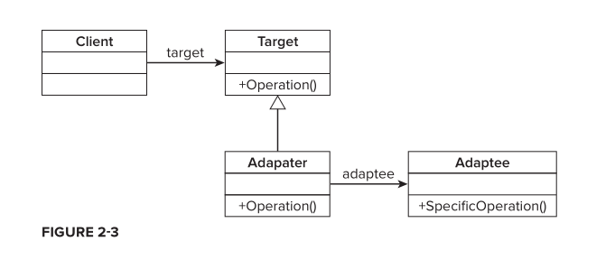

a client has a reference to an abstraction — the Target . In this case

this is the ICacheStorage interface. The Adapter is an implementation of the Target interface and

simply delegates the Operation method to the Adaptee , which runs its own SpecificOperation

method. You can see that the Adapter simply wraps an instance of the Adaptee and delegates the

work off to it while implementing the contract of the Target interface.

